21st International Conference on Hydrodynamics in Ship Design and Operation
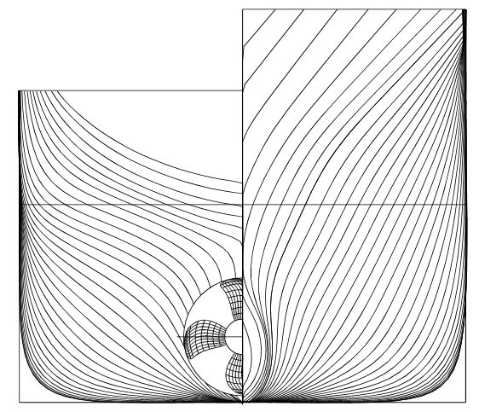
HYDRONAV 2017
Gdańsk, 28-29 June 2017
Title of paper (14 point Times New Roman bold font in 1.0 line spacing)
A. AUTHOR¹ and B. C. AUTHOR² (11 point Times New Roman font in 1.0 line spacing, uppercase letters)
¹ Affiliation, e-mail (9 point Times New Roman font in 1.0 line spacing)
² Affiliation, e-mail (9 point Times New Roman font in 1.0 line spacing)
These pages provide you with an example of the layout and style which we wish you to adopt during the preparation of your paper. All styles of titles, plain text, captions, etc. have been defined as HNV- styles for formatting of paragraphs in this document. Appropriate font sizes and types are also apparently given in the following text. The points mentioned below give the technical requirements to which your contribution should adhere. All text material and illustrations will be published without reduction. The text length shall be about 10 pages, including figures. Uniformly prepared engineering terms and informative abstracts are essential. Thus, the author plays a primary role in preparation of an abstract and keywords along with manuscript. An abstract of about 150 words should appear on the first page of paper. The abstract should be a concise statement of the principal findings and conclusion of the paper. Do not include mathematics and references in an abstract. (9 point Times New Roman font in 1.0 line spacing)
Keywords: cooper, composites, properties, model (8 point Times New Roman font in 1.0 line spacing)

Format (section title, 12 point Times New Roman bold font in 1.0 line spacing)
Text should be produced within the dimensions shown on these pages. Please use A4 paper size. All margins should be the same 2.5 cm. The title of the paper on the first page is mowed 4 lines down, as is visible on the instruction. Make use of the maximum stipulated length apart from the following two exceptions (i) do not begin a new section directly at the bottom of a page, but transfer the heading to the top of the next page; (ii) you may exceed the length of the text area by one line only in order to complete a section of text or a paragraph. Italics for emphasis. (11 point Times New Roman font in 1.0 line spacing)

Format (subsection title, 11 point Times New Roman bold font in 1.0 line spacing)
These instructions have been produced using Times New Roman as most recommended font.
This text has been prepared in accordance with the instruction. The file in Microsoft Word format can be downloaded from the Conference web site at: http://hydronav.pwr.wroc.pl .

Spacing
We recommend the use of 1.0 (single) line spacing. However, when typing complicated mathematical text it is important to increase the space between text lines in order to prevent sub- and super-script fonts overlapping one another and making your printed matter illegible. If you are using a desktop publishing program ensure that your `auto adjust' for interline spacing is suitably set to prevent overlapping but without leaving too much space.

Tables and illustrations
Tables and illustrations should be arranged throughout the text and preferably be included on the same page as they are first discussed. They should have a self-contained caption and be positioned in flush-left alignment with the text margin. Two small illustrations may be placed alongside one another as shown with Figures 1 and 2.

Tables
Tables should be presented in the form shown in Table 1. Their layout should be consistent throughout. If a table is too long to fit onto one page, the table number and headings should be repeated on the next page before the table is continued. Alternatively, the table can be spread over two consecutive pages (first an even-numbered, then an odd-numbered one) turned by 90°, without repeating the headings.
Table 1. Title of table (9 point Times New Roman font in 1.0 line spacing)
 | Pilot plant |  | Full scale plant
 | Influent | Effluent | Influent | Effluent
Total cyanide  Method-C cyanide  Thiocyanide  Ammonia  Copper  Suspended solids  (9 point Times New Roman font in 1.0 line spacing) | 6.5  4.1  60.0  6.0  1.0 | 0.35  0.05  1.0  0.50  0.04 | 2.0  50.0  1.0 | 0.30  0.02  <0.10  0.10  0.05  <10.0

Line drawings
Ensure that line weights will be 0.5 points or greater. Lines thinner than that will be reproduced poorly. Ensure a minimum of 8 pt type size within illustrations. Lettering on figures should be in a clear sans-serif typeface (e.g. Arial or Helvetica); if possible, the same type face should be used for all figures in the paper. Please note that this sort of font is in small text portions more legible than the Times font used in the main body text.
All notations and lettering should be no less than 2.0 mm high. The use of heavy black, bold lettering should be avoided as this will look unpleasantly dark when printed.
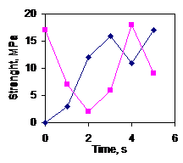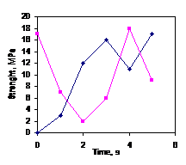
Fig. 1. Lettering is large enough Fig. 2. Lettering is correct
(9 point Times New Roman font in 1.0 line spacing)

Photographs
Photographs must always be sharp and rich in contrast. They will not undergo reduction and should be pasted on your page in the same way as line drawings.

Equations
Equations should be placed flush-left with the text margin and should be preceded and followed by one line of white.
Equation numbers flush right ↓
${\bar{u}}^{2}=\frac{9}{∂^{2}}\frac{h^{2}T}{{mkT}_{c}^{2}}\left(\frac{x_{r}}{4}+φ\left(x_{T}\right)\right)$ (1)
If they are numbered make sure that they are numbered consecutively. Place the numbers in parentheses flush with the right-hand margin and level with the last line of the equation.

References
[1] Mazurin O. V., Koshits E.A.: Phase Separation in Glass, North-Holland, Amsterdam, 1984.
[2] Damov V., Ramon S.: Sheet metal forming design, J. Mater. Sci., Vol. 10, No. 5, 1975, 1419.
[3] Eaton D.L., Porous Glass Support Material, US Patent, No. 3, 904 422, 1975.
(10 point Times New Roman font in 1.0 line spacing)

References should be collected at the end of your paper. Do not begin them on a new page unless this is absolutely necessary. They should be prepared according to a recognised style, e.g. the Harvard or sequential numeric system making sure that your accumulated list corresponds to the citations made in the text body and that all material mentioned is generally available to the reader. Above we have listed some references according to the numeric sequential system [1-3]. In this system references are numbered in the order in which they are cited in the text.

